Job Application Letter

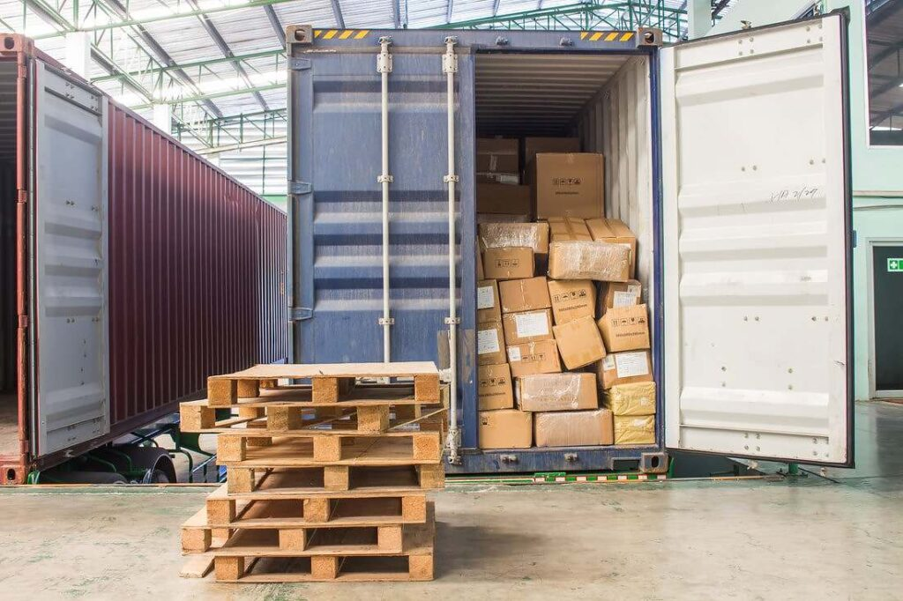

Davison Mejia

Address: Cra 1ª#7-03 Ansermanuevo Valle E-mail: [Andresmejiauwu98@gmail.com](mailto:Andresmejiauwu98@gmail.com) Mobile Phone: 3212615520 Date: 16/july/2024

Dear hiring company:

**Global cargo**

**PHONE:** +1 555 123-4567

**E-mail:** [globalcargoconnect@gmail.com](mailto:globalcargoconnect@gmail.com)

**Miami, Florida, EE. UU.**

**Matte:** **Application for the position of Export and Import Operations Specialist**

**Good Afternoon**

Cordial greetings, I identify myself with my citizenship card No. 1,116,435,477 issued in Ansermanuevo valle; At this time I want to tell you that I am working in the seaport of La Costa as a coordinator of container cargo shipments in advance, I want to let you know of my motivations and desires to work with this great company and I want to apply for the specialization in export and import operations, I want to tell you that I have a great experience and as the responsibility of my position as coordinator of my daily experience as a The management of land, sea and air transport I also have some strategies that I highlight to improve operational efficiency with my ability to efficiently manage inventory and supply chain with a knowledge of international trade regulations, my communication and teamwork is very fluent I also have the mastery of computer tools for logistics management. I'm excited about I have the opportunity to build on the success of Global Cargo with my experience and dedication to excellence in international freight forwarding as well as thank you for the attention you have given.

Davison Andrés Mejía Villada

C.C. 1.116.435.477

E-mail: [andresmejiauwu98@gmail.com](mailto:andresmejiauwu98@gmail.com)

Phone: +57 3212615520